Analysis of Marginal Costs with Newton Polynomial

A Case Study in CV. Online Media Indonesia

La Ode Muhammad Urfan*

School of Electrical Engineering and Informatics,

Bandung Institute of Technology,

Bandung, Indonesia,

laode.urfan@std.stei.itb.ac.id

*Abstract*—Marginal costs is one of the variable costs used to viewed the quality of company’s costs of productions. Marginal costs can be used to early update on the costs of productions state. We can analyze marginal costs by the costs function. We proposed method to calculate marginal costs by defining its costs function using newton polynomial and used the costs function to calculate the marginal costs from derivative of costs function. We then experiment on datasets of BPJS Transactions in Indonesia to evaluate our method. The results show that the proposed method is applicable for use on analysis of marginal costs.

Keywords; costs function; marginal costs; interpolation; newton polynomial

# Introduction

The one main concern of any companies is on the costs. The method to address the costs issue is to perform a costs analysis (also called costs-benefit analysis). The costs analysis is needed to run the detail of the potential gain or risks that company may face in the future. Every variables affecting the costs of the company (direct or not) are crucial factors that need to be included in analysis. Costs analysis useful to help deciding many types of business decisions.

One dimension of the costs analysis can be viewed by its marginal costs. Marginal costs often interpreted as the increase or decrease in the total costs. Marginal costs of a production run for making one additional unit of an item. Marginal costs are computed when the level of break-even has been reached. That is when the fixed costs have already been absorbed by the already produced items and only the direct variable of the costs have to be accounted for.

Marginal costs consist of labor and material expanse, including the amount of fixed costs (e.g. administration fees and sale expenses). Marginal costs of production are the change in total costs that comes from producing one additional item [1]. The standard Equation of marginal costs is written in Equation (1):

$MC=∆C/∆q$

where, $MC$ is marginal costs, $∆C$ is delta of total costs, and $∆q$ is delta of quantity.

Identifying marginal costs is critically important in resource allocation because to be able to achieve the optimum results, company must concentrate its resources where the excess of marginal revenue over the marginal costs is maximum.

The problem in identifying marginal costs is that even though the characteristic of datasets (i.e. total costs, fixed costs, quantity, etc.) that are used to calculate marginal costs are precise, it sometimes inconsistent. This happens because there are missing variable in the discrete data distributions. The other problem is that sometimes company need to identify marginal costs on data that are not present at the moment.

Therefore, in this paper, we described the approach in analysis of marginal costs by performing interpolation to calculate the definitive form of costs function. Then after that, marginal costs can be calculated by the derivative of the costs function we defined.

In this paper, we used data BPJS transactions, regional Indonesia. Datasets are retrieved from database from CV. Online Media Indonesia, a company who engaged in the field of Payment Point Online Bank (PPOB) in Indonesia.

# Costs Of Productions

## Economic Costs

The economic costs or opportunity costs is the value of the best alternative use of a resource. The economic costs include both explicit and implicit costs [2].

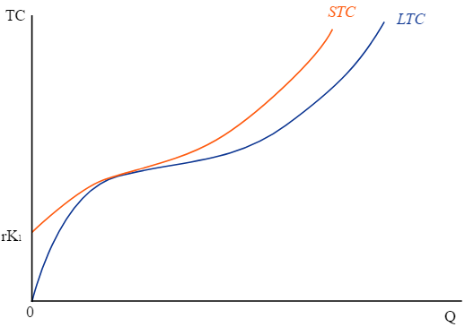

Fig 1. Long-run costs and Short-run Curve

*Source:http://commons.wikimedia.org/wiki/File:Relationshipsship_between_Long-run costs_Costs_Curve_and_Short-run_Costs_Curve.svg Wikimedia CC BY-SA.*

There are two types of economic costs: i.e. long-run costs and short-run. In this paper we focus on short-run costs to further process in costs function.

## Costs Curves

Costs curve shows a graph of the costs of production to the total quantity. As mention before costs curves are applicable to the short-run and the long-run costs.

The basic difference between long-run costs and short-run is that long-run costs have no fixed factors of production, while short-run have fixed factors and variables that will affect the production. The difference shown in Fig 1.

### Short-run Costs

Following are variable that have impact on costs of production.

**Costs levels** is the expanses for producing at certain level of output. In short-run, there is a fixed costs (*F*), a costs production that does not vary with output.

**Variable costs** (*VC*) is the expanses of production which relative to the change of quantity produced. Variable costs can be adjusted to alter its output level such as labor and materials.

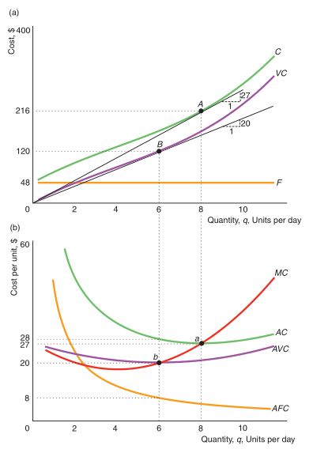

Fig 2. Short-run Curves

Source: Perloff, J. 2009. Microeconomics.

Relationships between variable costs and fixed costs shown in Equation (2):

$C=VC+F$

where *C* is total costs.

**Marginal costs** (*MC*) is the expanses which relative to the changes of one more unit of output. The marginal costs shown in Equation (3)

$MC=\frac{∆C}{∆q}$

we can eliminate fixed costs as only variable costs changes with output:

$MC=\frac{∆VC}{Aq}$

**Average fixed costs** (*AFC*) is the fixed expanses divided by the units of output.

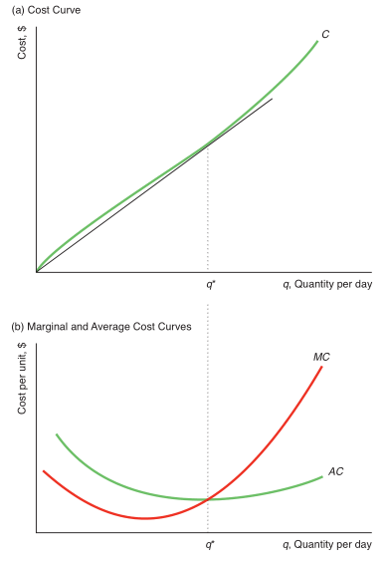

Fig 3. Short-run Curves

Source: Perloff, J. 2009. Microeconomics

**Average variable costs** (*AVC*) is the variable costs divided by the units of output produced

**Average costs** (*AC*) is the total costs divided by the units of output. The average costs are the sum of the average fixed costs and the average variable costs.

Relationships of variables in short-run (*C, VC, F, MC, AC, AVC, and AFC*) costs are shown in Fig 2.

### Long-run costs

In long-run costs, variable that have impact on costs of production are similar to variable in short-run costs, except that in long-run costs there is no fixed costs. Curves shapes completely relative to the average costs, and the marginal costs shapes relative to the shape of the long-run costs-costs curve. Relationships of these variable shown in Fig 3.

# Polynomial Interpolation

Interpolation is the method of matching or fitting the coordinate value of given data. This kind of method often called as curve matching or curve fitting. The method of interpolation is expected to approach the function which close to the exact function.

Interpolation best fits to datasets known to have high precision. In example, let *y = f(x)*, where variable *x* discrete for number of *n*. We can then define the function *f(x)* by performing interpolation on the datasets. Interpolation known by the possible type of curve it has: i.e.: linear interpolation, square interpolation, and polynomial interpolation. Illustration of interpolation on polynomial function shown in Fig 5.

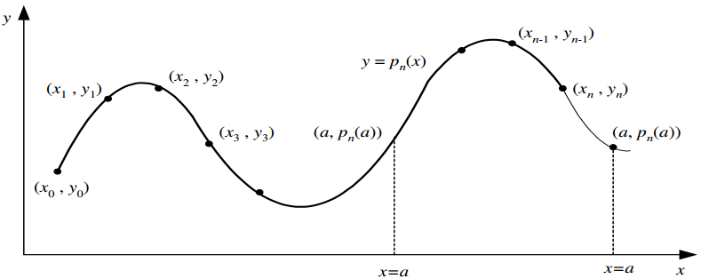

Fig 5. Polynomial Interpolation and Extrapolation

source: Munir, R. 2011. Metode Numerik.

Let *pn(x)* is the polynomial interpolation, *y* on *x = a*, so that *y = pn(a)*. Based on the position of *x*, the approach could be either interpolation or extrapolation.

1. Interpolation for *x0 < a < xn*.
2. Extrapolation for *x0 < xk* or *x0 < xn*

##### Newton Polynomial Interpolation

Let a linear polynomial as follow:

$P_{1}\left(x\right)=y_{o}+\frac{\left(y_{1}-y_{0}\right)}{\left(x_{1}-x_{0}\right)}(x-x_{0})$

we then write Equation as follow:

$P_{1}\left(x\right)=a_{o}+a_{1}(x-x_{0})$

where

$a_{o}=y_{o}=f(x_{o})$

$a_{1}=\frac{\left(y_{1}-y_{0}\right)}{\left(x_{1}-x_{0}\right)}= \frac{\left(f(x_{1})-f(x_{o})\right)}{\left(x_{1}-x_{0}\right)}$

Let shorts *a1* as follow:

$a_{1}=f[x_{1},x_{0}]$

The equation then expanded to the polynomial function with number of degree equal *n.*

$P_{1}\left(x\right)=a_{o}+a_{1}(x-x_{0})$

$P_{2}\left(x\right)=a_{o}+a_{1}(x-x_{0})+a_{2}(x-x_{0})(x-x_{1})$

$P_{3}\left(x\right)=a_{o}+a_{1}\left(x-x_{0}\right)+a_{2}\left(x-x_{0}\right)\left(x-x_{1}\right)+a_{3}(x-x_{0})(x-x_{1})(x-x_{2})$

…

$$P_{n}\left(x\right)=a_{o}+a_{1}\left(x-x_{0}\right)+a_{2}\left(x-x_{0}\right)\left(x-x_{1}\right)+a_{3}\left(x-x_{0}\right)\left(x-x_{1}\right)\left(x-x_{2}\right)+…+a_{n}\left(x-x_{0}\right)\left(x-x_{1}\right)…\left(x-x_{n-1}\right)$$

where *a* is constant variable defined as follow:

$$a_{o}=f(x_{o})$$

$$a_{1}=f[x_{1},x_{0}]$$

$$a_{1}=f[x_{2},x_{1},x_{0}]$$

…

$$a_{1}=f[x_{n},x_{n-1},…,x_{1},x_{0}]$$

where *f[x]* defined as follow:

$$f[x_{i},x_{j}]=\frac{f(x_{i})-f(x_{j})}{\left(x_{i}-x_{j}\right)}$$

$$f[x_{i},x_{j},x_{k}]=\frac{f[x_{i},x_{j}]-f[x_{j},x_{k}]}{\left(x_{i}-x_{k}\right)}$$

$$f[x_{n},…,x_{1},x_{0}]=\frac{f[x_{n},…,x_{1}]-f[x_{n-1},…,x_{0}]}{\left(x_{n}-x_{0}\right)}$$

Then after that, we can describe newton polynomial interpolation as follow:

1. Recurrence
$$P_{n}\left(x\right)=f\left(x_{o}\right)+f\left[x_{1},x_{0}\right]\left(x-x_{0}\right)+f\left[x_{2},x_{1},x_{0}\right]\left(x-x_{0}\right)\left(x-x_{1}\right)+…+f\left[x_{n},…,x_{0}\right]\left(x-x_{0}\right)… \left(x-x_{n-1}\right)$$

2. Base

$$P_{0}\left(x\right)= f\left(x_{o}\right)$$

The variable *f[x]* is better to put in the table, often called divided-difference table. This is one of the advantage of newton polynomial, where we can re-use the divided-difference table to perform the similar task on lower or higher degree without re-calculate from the beginning.

Table 1. Table of Divided-Difference

|  |  |  |  |  |  |
| --- | --- | --- | --- | --- | --- |
| *i* | *xi* | *f(xi)* | *dd-(1)* | *…* | *dd-(n-1)* |
| *0* | *x0* | *f(x0)* | *f[x0,x1]* | *…* | *f[xn,..,x0]* |
| *1* | *x1* | *f(x1)* | *f[x1,x2]* | *…* | *0* |
| *…* | *…* | *…* | *…* | *…* | *0* |
| *n* | *xn* | *f(xn)* | *0* | *…* | *0* |

# Datasets

We use datasets on payment transactions of Badan Penyelenggara Jaminan Sosial Kesehatan (BPJS Kesehatan) in regional Indonesia. We consider payment transactions of BPJS as one of the most frequent transactions occurred in Indonesia per month (beside PLN, PDAM, and TELKOM).

Datasets are retrieved from company CV. Online Media Indonesia database. Online Media Indonesia is a company that engaged in the field of Payment Online Service or Payment Point Online Bank (PPOB). Online Media Indonesia is one of the top service provider for payment via online in Indonesia.

##### Data transactions

We use datasets transactions of BPJS Kesehatan from July 2016 until April 2017. We collect the quantity of transactions and the total costs transactions. Datasets shown in Table 2.

Table 2. BPJS Transactions July 2016 to May 2017

|  |  |  |  |  |
| --- | --- | --- | --- | --- |
| Month | Year | Qty | Fixed Costs(IDR) | Costs(IDR) |
| JUL | 2016 | 120 | 2000000.00 | 9752662.00 |
| AUG | 2016 | 3723 | 2000000.00 | 253195160.00 |
| SEP | 2016 | 7409 | 2000000.00 | 1566910495.00 |
| OCT | 2016 | 10282 | 2000000.00 | 1712863539.00 |
| NOV | 2016 | 10831 | 2000000.00 | 1722208329.00 |
| DEC | 2016 | 11495 | 2000000.00 | 1695697254.00 |
| JAN | 2017 | 11604 | 2000000.00 | 1841403510.00 |
| FEB | 2017 | 12326 | 2000000.00 | 2232442910.00 |
| MAR | 2017 | 18039 | 2000000.00 | 2698754005.00 |
| APR | 2017 | 19214 | 2000000.00 | 2745480919.00 |
| MAY | 2017 | 10894 | 2000000.00 | 1406676393.00 |

# ANALYSIS MARGINAL COSTS (RESULT AND EVALUATION)

The method we proposed consists of two steps: the first step is to define costs function by given datasets (Table 2). The second step is to derivate the costs function to get the marginal costs function which later used to calculate the marginal costs.

## Define Costs-Function

We use numerical method of Newton Polynomial Interpolation to define function of given datasets. Process to define costs from datasets is two steps process: i.e. 1) Data Preparation; and 2) Newton Polynomial Interpolation.

#### Data Preparation

Before we can interpolate datasets, we need to prepare the datasets so that it can be accessible for Newton Interpolation.

1. Define initial *x* and *f(x)*

First, we define *x0* and *y0.* We know that *x0 =* 0, and *y0*in the case equals to the fixed costs from table, *y0 =* 2000000.

1. Define *xi* and *f(xi)*.

Next, we list every value of *xi* and *f(xi)*. The *f(xi)* are the total costs, so it’s sum of fixed costs and variable costs.

Table 3 shows the results of data preparation.

Table 3. *xi and f(xi)*

|  |  |
| --- | --- |
| *x* | *f(x)* |
| 0 | 2000000.00 |
| 120 | 11752662.00 |
| 3723 | 255195168.00 |
| 7409 | 1568910464.00 |
| 10282 | 1714863488.00 |
| 10831 | 1724208384.00 |
| 11495 | 1697697280.00 |
| 11604 | 1843403520.00 |
| 12326 | 2234442752.00 |
| 18039 | 2700753920.00 |
| 19214 | 2747481088.00 |

Fig 6 shows the curve of Table 3.

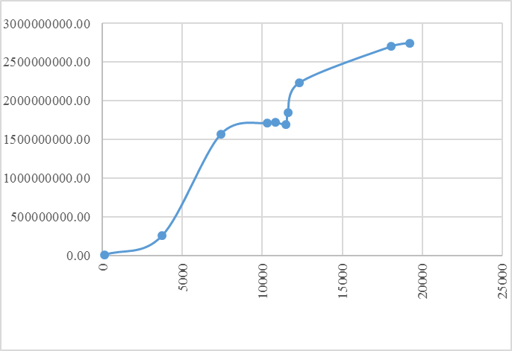

Fig 6. Curve of Costs to Quantity

#### Newton Polynomial Interpolation

Now we are ready to perform Newton Polynomial Interpolation on given data (see Table 3).

The goal of this step is to get the constant of costs-function. It can be retrieved from the divided-difference table. We use program Newton Interpolation written in C language to do this task.

The results of divided-difference table shown in Table 5. As shown in Table 5, the constant of function are *f(xi)* and *dd-(1 … (n-1))* from the first row.

We don’t need to do the further interpolation as the goal to get constant already achieved. These constants will be used in the next step which will define the costs function.

Table 5. Divided-Difference



## Derivative of Costs-Function

The derivative of costs-functions is marginal costs function. We simply write the newton interpolation with the *x0 = 0*, then we get the costs function as Equation 13.

$$Pn\left(x\right)= 2E+06+81272*(x-0.00)*+-3.681*(x-0.00)*(x-120.00)+0.006*(x-0.00)*(x-120.00)*(x-3723.00)+-1E-06*(x-0.00)*(x-120.00)*(x-3723.00)*(x-7409.00)+2E-10*(x-0.00)*(x-120.00)*(x-3723.00)*(x-7409.00)*(x-10282.00)+-5E-14*(x-0.00)*(x-120.00)*(x-3723.00)*(x-7409.00)*(x-10282.00)*(x-10831.00)+3E-16*(x-0.00)*(x-120.00)*(x-3723.00)*(x-7409.00)*(x-10282.00)*(x-10831.00)*(x-11495.00)+-4E-19*(x-0.00)*(x-120.00)*(x-3723.00)*(x-7409.00)*(x-10282.00)*(x-10831.00)*(x-11495.00)*(x-11604.00)+6E-23*(x-0.00)*(x-120.00)*(x-3723.00)*(x-7409.00)*(x-10282.00)*(x-10831.00)*(x-11495.00)*(x-11604.00)*(x-12326.00)+-8E-27*(x-0.00)*(x-120.00)*(x-3723.00)*(x-7409.00)*(x-10282.00)*(x-10831.00)*(x-11495.00)*(x-11604.00)*(x-12326.00)*(x-18039.00)$$

Equation *Pn(x)* can be simplify if needed, but we will not discuss any further about this issue in this paper. This costs function is enough to be used for calculating marginal costs.

Derivative of costs function is marginal costs function. Say we need to calculate marginal costs on *x = 10282.0*, it’s done by calculate the value of *f’(10282.0000000)*. Where *f’* is derivative of *f.*

We perform numerical method, Runge Kutta 3 to calculate the derivative of costs function. We use program Runge Kutta 3 written in C language to do this task. Fig 7 shows the result of derivation with *h=3* of given costs-function.

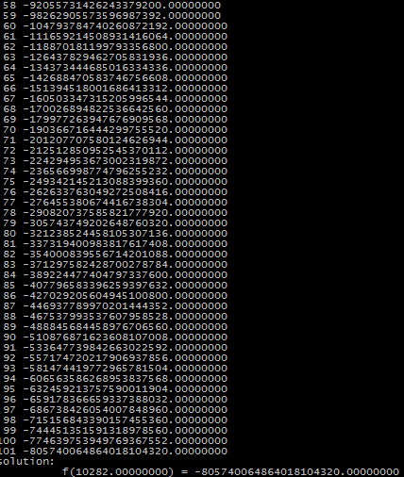

Fig 7. Screenshots Derivative of Costs Function

with Runge Kutta 3

##### EVALUATION MARGINAL COSTS

We show the relationships of Marginal Costs and Average Total Costs in the Fig 8.

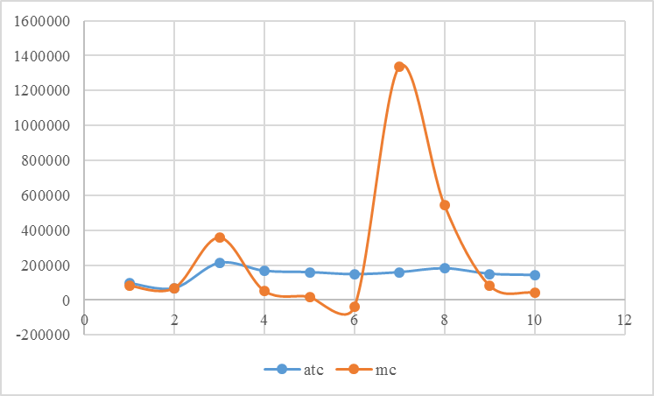

Fig 8. Marginal Costs and Average Total Costs

Based on Fig 8, we realized that the type of costs on BPJS transactions in Online Media Indonesia is a Short-Run Costs. We also realized from result of derivation costs function that the interpolation to the given datasets may not fit. It is shown from the impact on calculation marginal a bit mismatch.

# Conclusions

We conclude several point based on the results we have:

1. Interpolation, follows with the derivative can be used to analyze marginal costs.
2. There is a bit difference between marginal costs from per discrete data and the marginal costs from calculated using our prosed method.

##### Future Works

The potential to explore analysis marginal costs using different interpolation method: like Lagrange. We also notice there’s room for improvement on datasets to see the best fit of interpolation in the use for analysis marginal function.

##### Acknowledgment

We give thanks to The Director of CV. Online Media Indonesia who gave access to the database of transactions data that are used in this paper.

##### References

1. Robert E. Hall. 1988. The Relationships between Price and Marginal Costs in U.S. Industry. Journal of Political Economy 96, no. 5 (Oct., 1988): 921-947.
2. Perloff, J. 2009. Microeconomics, 5th ed. Pearson.
3. Munir, R. 2011. Metode Numerik. Intitut Teknologi Bandung. Bandung.
4. S. Chapra, Applied Numerical Methods with Matlab, 3 rd ed, McGraw-

Hill, 2011

STATEMENT

I hereby declare that this paper is written by me in my own words, not an adaptation or translation of another paper, and certainly not a result of plagiarism.

Bandung, 12 Mei 2016

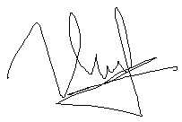

La Ode Muhammad Urfan/23516065