**Jawaban Kuis 1 2019**

1.

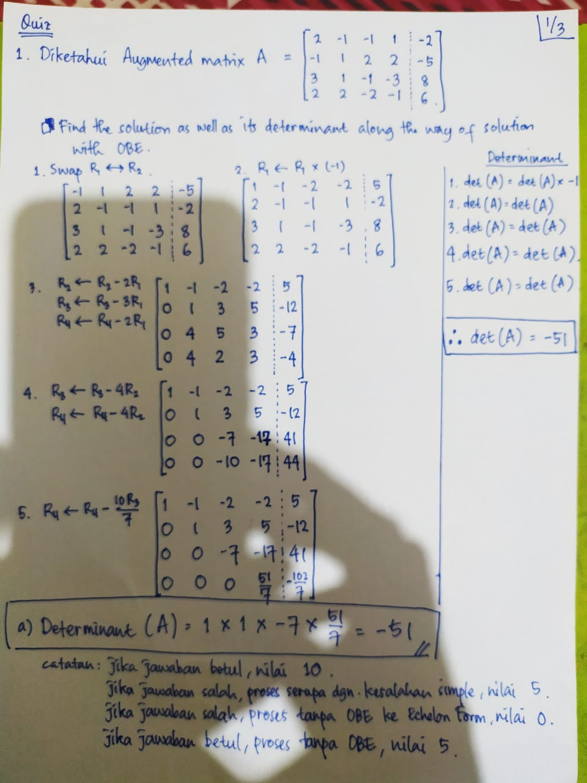

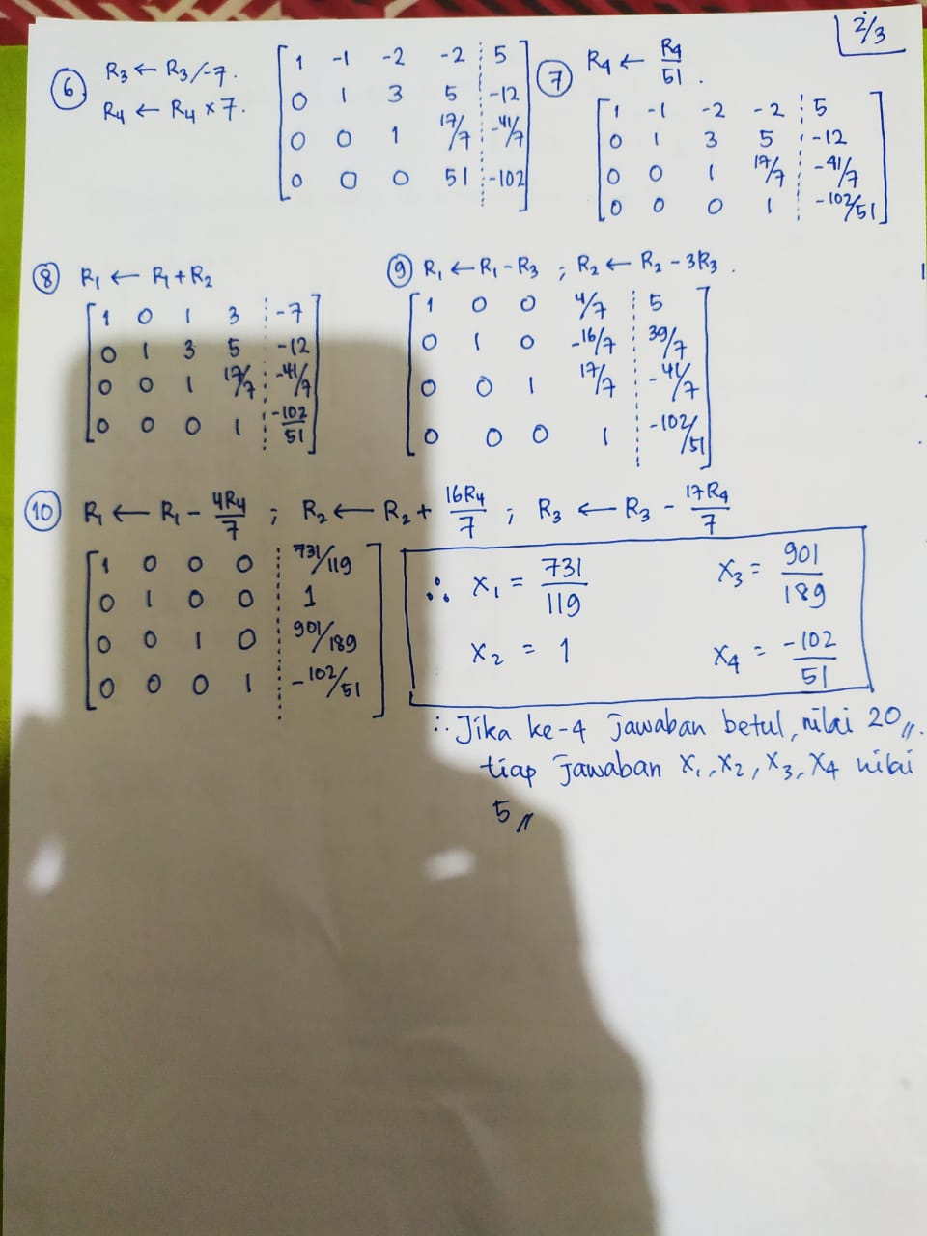

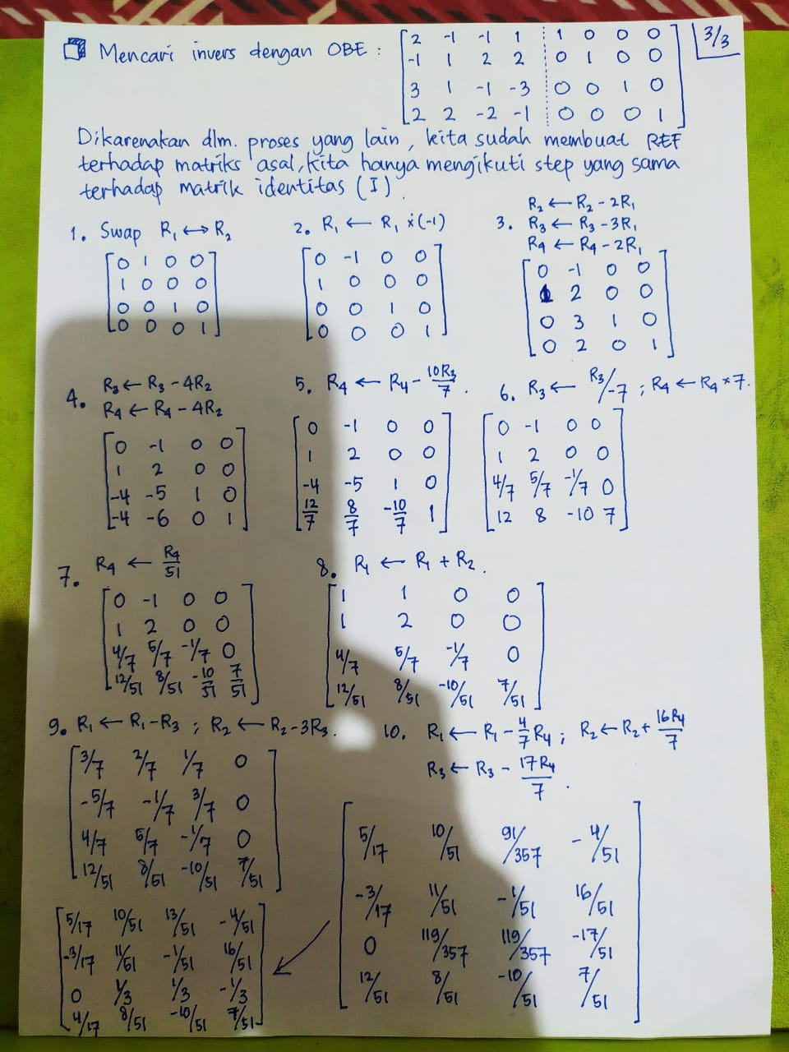

2.

(a) 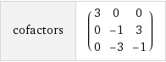

(b) det (A) = 30

A-1 = 1/det(A) adj(A) = 1/30  = 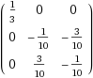

3. a) - 56 b) 8/(-7) c) 7