Analytic Hierarchy Process (What is AHP)
Analytic Hierarchy Process (AHP) is one of Multi Criteria decision making method that was originally developed by Prof. Thomas L. Saaty. In short, it is a method to derive ratio scales from paired comparisons. The input can be obtained from actual measurement such as price, weight etc., or from subjective opinion such as satisfaction feelings and preference. AHP allow some small inconsistency in judgment because human is not always consistent. The ratio scales are derived from the principal Eigen vectors and the consistency index is derived from the principal Eigen value.
Don't worry if you don't understand yet about all of those terminologies above because the purpose of this tutorial is to explain that in a very simple way. You just need to read on and at the end you will understand.
Pair-wise Comparison (What is pair-wise comparison?)
Now let me explain what paired comparison is. It is always easier to explain by an example. Suppose we have two fruits Apple and Banana. I would like to ask you, which fruit you like better than the other and how much you like it in comparison with the other. Let us make a relative scale to measure how much you like the fruit on the left (Apple) compared to the fruit on the right (Banana).
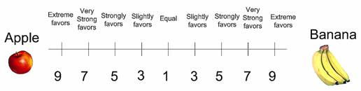
If you like the apple better than banana, you thick a mark between number 1 and 9 on left side, while if you favor banana more than apple, then you mark on the right side.
For instance I strongly favor banana to apple then I give mark like this
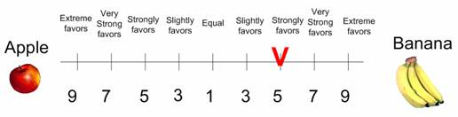
Now suppose you have three choices of fruits. Then the pair wise comparison goes as the following
 | 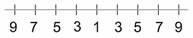 | 
 |  | 
You may observe that the number of comparisons is a combination of the number of things to be compared. Since we have 3 objects (Apple, Banana and Cheery), we have 3 comparisons. Table below shows the number of comparisons.
Table 7: Number of comparisons
Number of things | 1 | 2 | 3 | 4 | 5 | 6 | 7
number of comparisons | 0 | 1 | 3 | 6 | 10 | 15 | 21 | 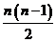
The scaling is not necessary 1 to 9 but for qualitative data such as preference, ranking and subjective opinions, it is suggested to use scale 1 to 9.
In the next section you will learn how to analyze this paired comparisons
Making Comparison Matrix (How to make reciprocal matrix?)
By now you know how to make paired comparisons. In this section you will learn how to make a reciprocal matrix from pair wise comparisons.
For example John has 3 kinds of fruits to be compared and he made subjective judgment on which fruit he likes best, like the following
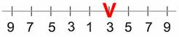

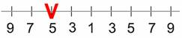

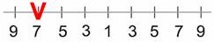

We can make a matrix from the 3 comparisons above. Because we have three comparisons, thus we have 3 by 3 matrix. The diagonal elements of the matrix are always 1 and we only need to fill up the upper triangular matrix. How to fill up the upper triangular matrix is using the following rules:
- If the judgment value is on the left side of 1, we put the actual judgment value.
- If the judgment value is on the right side of 1, we put the reciprocal value .
Comparing apple and banana, John slightly favor banana, thus we put in the row 1 column 2 of the matrix. Comparing Apple and Cherry, John strongly likes apple, thus we put actual judgment 5 on the first row, last column of the matrix. Comparing banana and cherry, banana is dominant. Thus we put his actual judgment on the second row, last column of the matrix. Then based on his preference values above, we have a reciprocal matrix like this
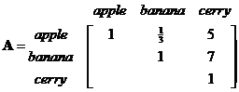
To fill the lower triangular matrix, we use the reciprocal values of the upper diagonal. If is the element of row column of the matrix, then the lower diagonal is filled using this formula
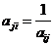
Thus now we have complete comparison matrix
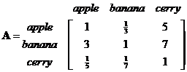
Notice that all the element in the comparison matrix are positive, or .
Next section will discuss about how you will use this matrix.
Priority Vectors (How to compute Eigen Value and Eigen vector?)
Having a comparison matrix, now we would like to compute priority vector, which is the normalized Eigen vector of the matrix. If you would like to know what the meaning of Eigen vector and Eigen value is and how to compute them manually, go to my other tutorial and then return back here. The method that I am going to explain in this section is only an approximation of Eigen vector (and Eigen value) of a reciprocal matrix. This approximation is actually worked well for small matrix and there is no guarantee that the rank will not reverse because of the approximation error. Nevertheless it is easy to compute because all we need to do is just to normalize each column of the matrix. At the end I will show the error of this approximation.
Suppose we have 3 by 3 reciprocal matrix from paired comparison
We sum each column of the reciprocal matrix to get
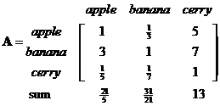
Then we divide each element of the matrix with the sum of its column, we have normalized relative weight. The sum of each column is 1.
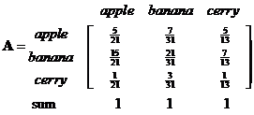
The normalized principal Eigen vector can be obtained by averaging across the rows
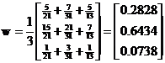
The normalized principal Eigen vector is also called priority vector . Since it is normalized, the sum of all elements in priority vector is 1. The priority vector shows relative weights among the things that we compare. In our example above, Apple is 28.28%, Banana is 64.34% and Cherry is 7.38%. John most preferable fruit is Banana, followed by Apple and Cheery. In this case, we know more than their ranking. In fact, the relative weight is a ratio scale that we can divide among them. For example, we can say that John likes banana 2.27 (=64.34/28.28) times more than apple and he also like banana so much 8.72 (=64.34/7.38) times more than cheery.
Aside from the relative weight, we can also check the consistency of John's answer. To do that, we need what is called Principal Eigen value. Principal Eigen value is obtained from the summation of products between each element of Eigen vector and the sum of columns of the reciprocal matrix.
Computation and the meaning of consistency are explained in the next section.
As a note, I put the comparison matrix into Matlab to see how different is the result of numerical computation of Eigen value and Eigen vector compared to the approximation above.
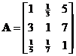
We get three Eigen vectors concatenated into 3 columns of matrix
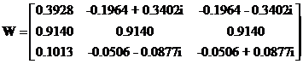
The corresponding Eigen values are the diagonal of matrix
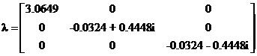
The largest Eigen value is called the Principal Eigen value, that is which is very close to our approximation (about 1% error). The principal Eigen vector is the Eigen vector that corresponds to the highest Eigen value.
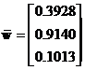
The sum is 1.4081 and the normalized principal Eigen vector is
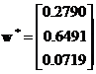
This result is also very close to our approximation
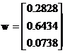
Thus the approximation is quite good.
Thus the sum of Eigen vector is not one. When you normalized an Eigen vector, then you get a priority vector. The sum of priority vector is one.
In next section you will learn how to make use of information of principal eige value to measure whether the opinion is consistent.
Consistency Index and Consistency Ratio (What is the meaning of consistent?)
What is the meaning that our opinion is consistent? How do we measure the consistency of subjective judgment? At the end of this section will be able to answer those questions.
Let us look again on John's judgment that we discussed in the previous section. Is John judgment consistent or not?

First he prefers Banana to Apple. Thus we say that for John, Banana has greater value than Apple. We write it as .
Next, he prefers Apple to Cherry. For him, Apple has greater value than Cherry. We write it as .
Since and , logically, we hope that or Banana must be preferable than Cherry. This logic of preference is called transitive property. If John answers in the last comparison is transitive (that he like Banana more than Cherry), then his judgment is consistent. On the contrary, if John prefers Cherry to Banana then his answer is inconsistent. Thus consistency is closely related to the transitive property.
A comparison matrix is said to be consistent if for all , and . However, we shall not force the consistency. For example, has value and has value , we shall not insist that must have value . This too much consistency is undesirable because we are dealing with human judgment. To be called consistent , the rank can be transitive but the values of judgment are not necessarily forced to multiplication formula .

Prof. Saaty proved that for consistent reciprocal matrix, the largest Eigen value is equal to the number of comparisons, or . Then he gave a measure of consistency, called Consistency Index as deviation or degree of consistency using the following formula

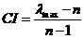

Thus in our previous example, we have and three comparisons, or , thus the consistency index is
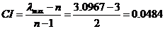
Knowing the Consistency Index, the next question is how do we use this index? Again, Prof. Saaty proposed that we use this index by comparing it with the appropriate one. The appropriate Consistency index is called Random Consistency Index ( ).
He randomly generated reciprocal matrix using scale , , …, , …, 8, 9 (similar to the idea of Bootstrap) and get the random consistency index to see if it is about 10% or less. The average random consistency index of sample size 500 matrices is shown in the table below
Table 8: Random Consistency Index ( )
n | 1 | 2 | 3 | 4 | 5 | 6 | 7 | 8 | 9 | 10
RI | 0 | 0 | 0.58 | 0.9 | 1.12 | 1.24 | 1.32 | 1.41 | 1.45 | 1.49
Then, he proposed what is called Consistency Ratio, which is a comparison between Consistency Index and Random Consistency Index, or in formula
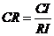
If the value of Consistency Ratio is smaller or equal to 10%, the inconsistency is acceptable. If the Consistency Ratio is greater than 10%, we need to revise the subjective judgment.
For our previous example, we have and for is 0.58, then we have 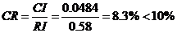. Thus, John's subjective evaluation about his fruit preference is consistent.
So far, in AHP we are only dealing with paired comparison of criteria or alternative but not both. In next section, I show an example to use both criteria and alternative in two levels of AHP.
Illustrative example (how to compute in a full hierarchy?)
In this section, I show an example of two levels AHP. The structure of hierarchy in this example can be drawn as the following
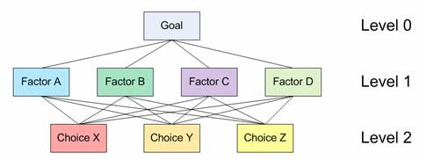
Level 0 is the goal of the analysis. Level 1 is multi criteria that consist of several factors. You can also add several other levels of sub criteria and sub-sub criteria but I did not use that here. The last level (level 2 in figure above) is the alternative choices. You can see again Table 1 for several examples of Goals, factors and alternative choices. The lines between levels indicate relationship between factors, choices and goal. In level 1 you will have one comparison matrix corresponds to pair-wise comparisons between 4 factors with respect to the goal. Thus, the comparison matrix of level 1 has size of 4 by 4. Because each choice is connected to each factor, and you have 3 choices and 4 factors, then in general you will have 4 comparison matrices at level 2. Each of these matrices has size 3 by 3. However, in this particular example, you will see that some weight of level 2 matrices are too small to contribute to overall decision, thus we can ignore them.
Based on questionnaire survey or your own paired comparison, we make several comparison matrices. Click here if you do not remember how to make a comparison matrix from paired comparisons. Suppose we have comparison matrix at level 1 as table below. The yellow color cells in upper triangular matrix indicate the parts that you can change in the spreadsheet. The diagonal is always 1 and the lower triangular matrix is filled using formula .
Table 9: Paired comparison matrix level 1 with respect to the goal
Criteria | A | B | C | D | Priority Vector
A | 1.00 | 3.00 | 7.00 | 9.00 | 57.39%
B | 0.33 | 1.00 | 5.00 | 7.00 | 29.13%
C | 0.14 | 0.20 | 1.00 | 3.00 | 9.03%
D | 0.11 | 0.14 | 0.33 | 1.00 | 4.45%
Sum | 1.59 | 4.34 | 13.33 | 20.00 | 100.00%
=4.2692, CI = 0.0897, CR = 9.97% < 10% (acceptable)

The priority vector is obtained from normalized Eigen vector of the matrix. Click here if you do not remember how to compute priority vector and largest Eigen value from a comparison matrix. CI and CR are consistency Index and Consistency ratio respectively, as I have explained in previous section. For your clarity, I include again here some part of the computation:
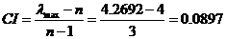
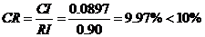(Thus, OK because quite consistent)

Random Consistency Index (RI) is obtained from Table 8.
Suppose you also have several comparison matrices at level 2. These comparison matrices are made for each choice, with respect to each factor.
Table 10: Paired comparison matrix level 2 with respect to Factor A
Choice | X | Y | Z | Priority Vector
X | 1.00 | 1.00 | 7.00 | 51.05%
Y | 1.00 | 1.00 | 3.00 | 38.93%
Z | 0.14 | 0.33 | 1.00 | 10.01%
Sum | 2.14 | 2.33 | 11.00 | 100.00%
=3.104, CI = 0.05, CR = 8.97% < 10% (acceptable)

Table 11: Paired comparison matrix level 2 with respect to Factor B
Choice | X | Y | Z | Priority Vector
X | 1.00 | 0.20 | 0.50 | 11.49%
Y | 5.00 | 1.00 | 5.00 | 70.28%
Z | 2.00 | 0.20 | 1.00 | 18.22%
Sum | 8.00 | 1.40 | 6.50 | 100.00%
=3.088, CI = 0.04, CR = 7.58% < 10% (acceptable)

We can do the same for paired comparison with respect to Factor C and D. However, the weight of factor C and D are very small (look at Table 9 again, they are only about 9% and 5% respectively), therefore we can assume the effect of leaving them out from further consideration is negligible. We ignore these two weights as set them as zero. So we do not use the paired comparison matrix level 2 with respect to Factor C and D. In that case, the weight of factor A and B in Table 9 must be adjusted so that the sum still 100%
Adjusted weight for factor A = 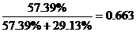

Adjusted weight for factor B = 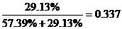

Then we compute the overall composite weight of each alternative choice based on the weight of level 1 and level 2. The overall weight is just normalization of linear combination of multiplication between weight and priority vector.

Table 12: Overall composite weight of the alternatives
 | Factor A | Factor B | Composite Weight
(Adjusted) Weight | 0.663 | 0.337
Choice X | 51.05% | 11.49% | 37.72%
Choice Y | 38.93% | 70.28% | 49.49%
Choice Z | 10.01% | 18.22% | 12.78%
For this example, we get the results that choice Y is the best choice, followed by X as the second choice and the worst choice is Z. The composite weights are ratio scale. We can say that choice Y is 3.87 times more preferable than choice Z, and choice Y is 1.3 times more preferable than choice X.
We can also check the overall consistency of hierarchy by summing for all levels, with weighted consistency index (CI) in the nominator and weighted random consistency index (RI) in the denominator. Overall consistency of the hierarchy in our example above is given by

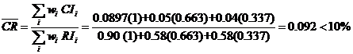(Acceptable)

Final Remark
By now you have learned several introductory methods on multi criteria decision making (MCDM) from simple cross tabulation, using rank, and weighted score until AHP. Using Analytic Hierarchy Process (AHP), you can convert ordinal scale to ratio scale and even check its consistency.

